Name: Ayman Khan   
Assignment 1   
  
  
S3:   
  
  
1) 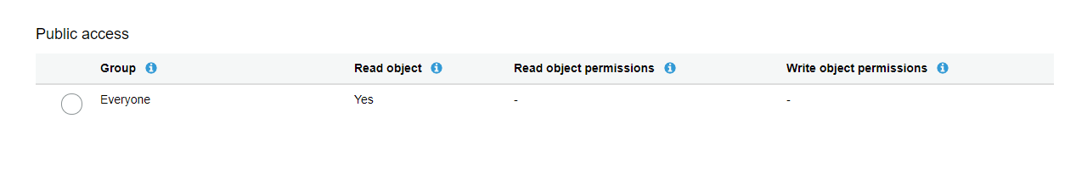  
I made sure that my AWS bucket was accessible by the public as this would come into play during the EC2 section of this assignment.   
  
  
2)   
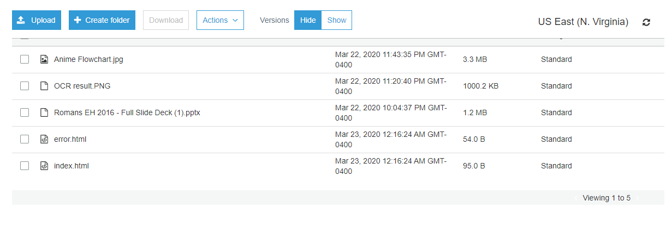  
As shown above, I had a few files in my AWS bucket. The file I would access is the index.html file.   
  
  
  
  
  
  
  
  
  
  
  
  
3)   
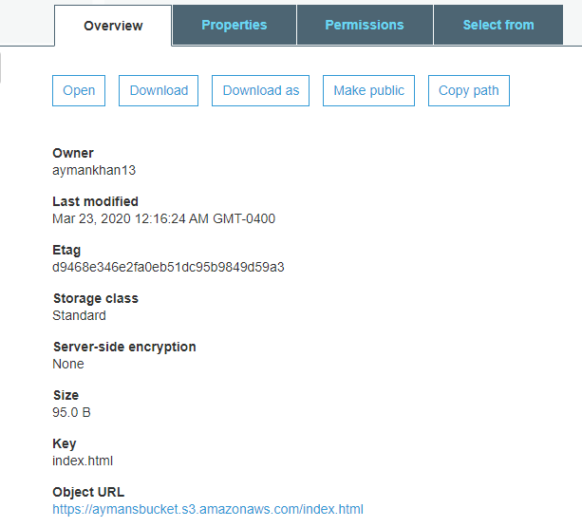  
After clicking on index.html, the details above are displayed. By clicking on the Object URL, the site will be accessed.   
  
4)   
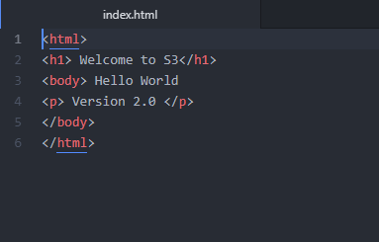  
This is the code in the index.html file.   
  
  
5)   
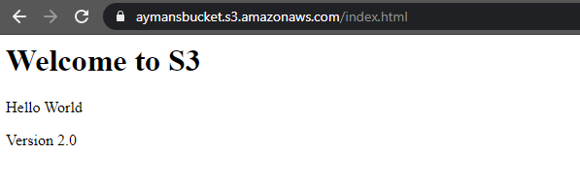  
After accessing the aforementioned object URL, the page shown above was accessed.   
  
  
  
EC2:   
  
1) 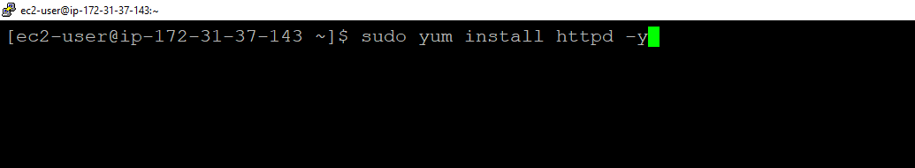  
After opening my AWS instance (while making sure ports 22, 80 and 443 were included in the Security groups) I updated my instance and then installed the Apache webserver.   
  
2) 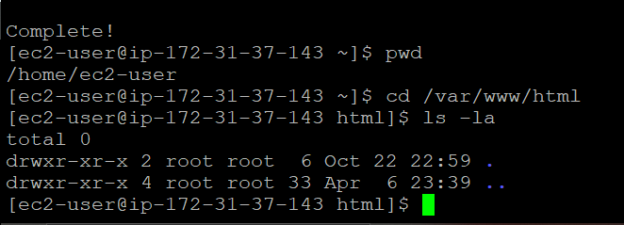  
  
After installing Apache, I changed directories into /var/www/html. Although I later learnt that the .html file has to be in the /www directory and not in the /html directory, I first downloaded my index.html into the /html directory.   
  
3)   
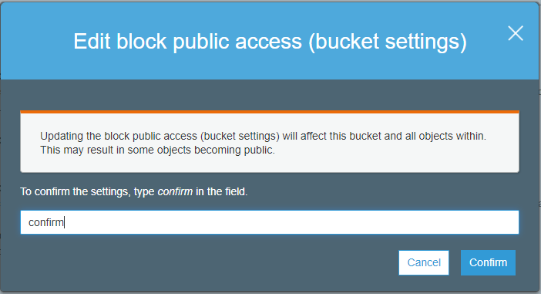  
After unsuccessfully trying to download the index.html file from my AWS bucket, I made the changes seen above; changing the public access on the bucket so that I could download the file into the /html directory.   
  
  
4)   
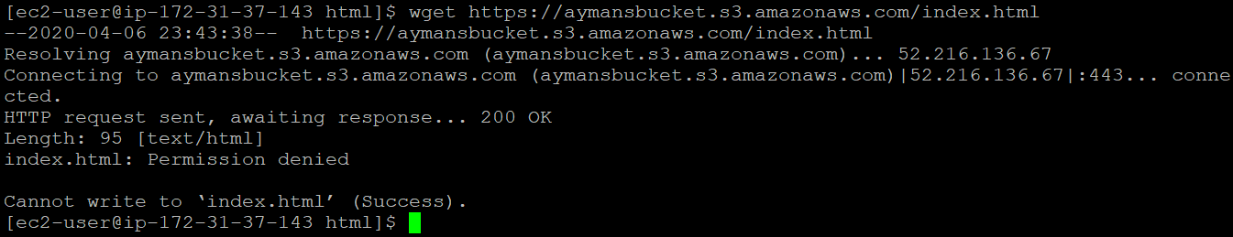  
  
After making the changes in the step 5, the download was successful.

5)   
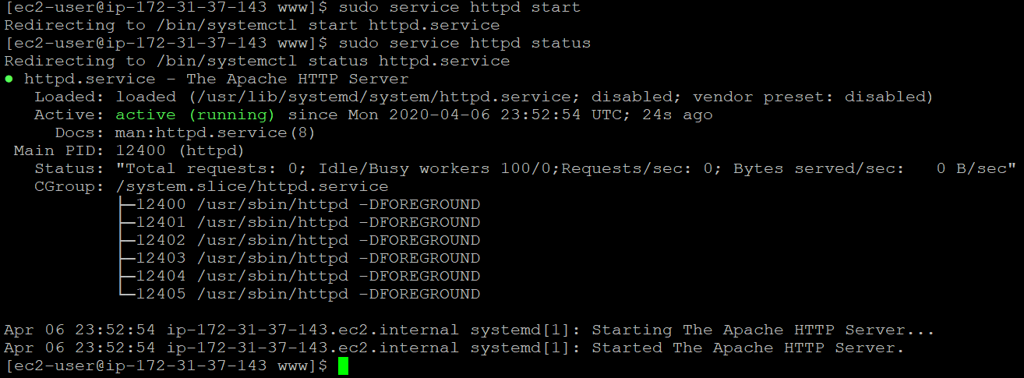  
After downloading the file again into /www directory, I started the apache service and checked the status as seen above. Seeing that it was running, I proceeded to view the webpage.   
  
  
6)   
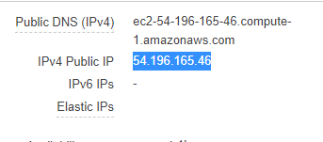  
After copying the Public IP of the instance, I pasted it into the browser.   
  
  
7)   
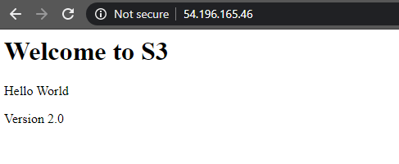  
As seen above, the website was running successfully.